

**COLLEGE OF APPLIED SCIENCES AND PROFESSIONAL STUDIES CHIKHLI (CASPS)**

**AFFILATED BY:**

**VEER NARMAD SOUTH GUJARAT UNIVERSITY.**

BACHELOR OF COMPUTER APPLICATION(B.C.A)

**(3RD YEAR / 6TH SEM)**

**PROJECT ON “HR Management System”**

***GUIDED BY: Dr. Ashoksingh Solanki***

**SUBMITTED BY: Pratham Sunil Kumar Danawala**



# **CERTIFICATE**

This is to certify that the project work carried out at **CASPS, Chikhli** and recorded in this report is the Bonafide work of **Pratham Sunilkumar Danawala** of Bachelor Of Computer Application Semester VI, and has been successfully carried out by him as partial fulfillment towards the degree of B.C.A., under our guidance during the academic year 2024-2025.

He was involved in the project for about eight weeks and was responsible for the design and development of **HR mangement system** at college as **In-house Project.**



**ACKNOWLEDGEMENT**

* I would like to express my sincere gratitude to **College of Applied Science and Professional Studies** **Chikhli** for providing me with the opportunity to work on this project, **HR Management System**. This project has been a valuable learning experience, allowing me to apply my theoretical knowledge to practical implementation.
* I extend my deepest appreciation to **my project guide, Dr. Ashok Singh Solanki**, for his continuous guidance, encouragement, and insightful feedback throughout the project. His expertise and valuable suggestions have been instrumental in shaping this project successfully.
* I am also immensely grateful to our esteemed **Principal, Dr. Ashok Singh Solanki**, for his unwavering support and for fostering an environment that encourages innovation and research. His leadership and motivation have greatly inspired me throughout this journey.
* Additionally, I would like to thank my faculty members, friends, and family for their constant encouragement, support, and motivation during this project. Their insights and feedback have helped me improve and refine my work.
* Lastly, I acknowledge the contributions of various resources, research materials, and technological tools that assisted in the development of this system. Their accessibility and guidance have played a significant role in making this project a success.
* With heartfelt gratitude, I dedicate this project to everyone who has supported me in this endeavour.

**ABSTRACT**

* The **HR Management System** is designed to streamline and automate human resource processes within an organization.
* It aims to enhance the efficiency of HR activities such as **employee management, attendance tracking, payroll processing,** **Project management,** **and leave management.**
* This system provides a user-friendly interface for HR professionals to manage employee records, monitor attendance, and ensure smooth payroll transactions. By reducing manual efforts and minimizing errors, the system enhances workforce productivity and supports data-driven decision-making.
* Implemented using **PHP, MySQL, HTML, CSS**, **JavaScript , J-query** and integrated with **Razorpay for salary payments ,** this system is a modern solution for HR management.

**OBJECTIVES**

The **HR Management System** is designed to automate HR operations, improving efficiency in employee management, attendance tracking, leave management, payroll processing, and communication. It has two panels:

1. HR Side
2. Employee Side

**1. HR Side**

**A. Organization Management**

* Maintain **department names and designation structures.**
* Ability to **add, edit, and delete** department names and designation names.

**B. Employee Management**

* **Add, edit, and delete** employee records.
* When a new employee is added, the system **sends a registration email** with login credentials and a welcome message.

**C. Attendance Management**

* Mark **bulk and single** attendance.
* Generate **daily/monthly attendance reports** for tracking employee attendance.
* **Download attendance reports** in PDF format.

**D. Leave Management**

* Maintain a **holiday calendar** for reference.
* Manage **leave applications** (approve/reject employee leave requests).
* Generate **leave reports** and **download them in PDF format**.

**E. Project Management**

* **Add, edit, and delete** projects.
* Assign employees to specific projects.
* Track project progress and employee participation.

**F. Payroll System**

* **First step:** Employees **request payroll processing**.
* **Second step:** HR **approves payroll** after verification.
* Provide **three salary payment options**:
  1. **Direct Bank Transfer (DBT) –** For bulk salary processing.
  2. **Online Payment –** Using **Razor pay** for single employee payments.
  3. **Cheque Payment –** For manual transactions.
* **Download salary slips** in PDF format after approval.

**G. Notice Management**

* HR can create, edit, and publish **official notices** for employees.

**2. Employee Side**

**A. Profile Management**

* Employees can view and update their **profile information**.

**B. Attendance Management**

* Employees can **See their attendance** .
* View **attendance reports** for daily and monthly records.
* **Download attendance reports** in PDF format.

**C. Leave Management**

* View the **holiday calendar**.
* **Apply for leave** and track leave status (Approved/Pending/Rejected).
* View **leave history reports** and **download them in PDF format**.

**D. Project Management**

* Employees can see the **projects assigned** to them.
* Track project deadlines and progress.

**E. Payroll System**

* Employees **request salary processing** from HR.
* After approval, employees can **view their salary details**.
* **Download Salary Slips** in PDF format after HR approval.

**F. Notices & Announcements**

* Employees can view **official notices** from HR.

**INDEX**

|  |  |  |  |
| --- | --- | --- | --- |
| Sr. No. |  | DESCRIPTION | Page No. |
| 1 |  | **INTRODUCTION** |  |
|  | 1.1 | Overview of the HRMS | 9 |
|  | 1.2 | Purpose of the System | 9 |
|  | 1.3 | Scope of the System | 10 |
|  | 1.4 | System Users & Roles | 11 |
|  | 1.5 | Advantages of the System | 11 |
|  |  |  |  |
| 2 |  | **SYSTEM REQUIREMENTS** |  |
|  | 2.1 | Hardware Requirements | 13 |
|  | 2.2 | Software Requirements | 13 |
|  | 2.3 | Development Tools & Technologies Used | 14 |
|  |  |  |  |
| 3 |  | **SOFTWARE DEVELOPMENT METHODOLOGY** |  |
|  | 3.1 | Waterfall Model Overview | 16 |
|  | 3.2 | Phases of the Waterfall Model | 17 |
|  |  |  |  |
| 4 |  | **SYSTEM DESIGN** |  |
|  | 4.1 | Entity-Relationship Diagram (ERD) | 19 |
|  | 4.2 | Data Flow Diagrams (DFD) | 20 |
|  |  |  |  |
| 5 |  | **SYSTEM IMPLEMENTATION** |  |
|  | 5.1 | Database Design | 23 |
|  | 5.2 | User Interface Screenshots | 28 |
|  |  |  |  |
| 6 |  | **CONCLUSION & FUTURE ENHANCEMENTS** |  |
|  | 7.1 | Conclusion | 49 |
|  | 7.2 | Future Scope & Improvements | 50 |
|  |  |  |  |
| 7 |  | **BIBLIOGRAPHY / REFERENCES** | 51 |

**INTRODUCTION**

**1.1 Overview of the HRMS**

* A **Human Resource Management System (HRMS)** is an integrated software solution designed to automate and streamline various HR functions within an organization.
* The system manages **employee records, attendance, payroll, leave, and project assignments** efficiently.
* By digitizing HR processes, it enhances productivity, reduces manual workload, and ensures accurate data management.
* This HRMS provides a **centralized platform** where HR administrators can handle core HR tasks, employees can access self-service portals, and payroll processing is simplified with multiple payment options, including **direct bank transfers, online payments (Razor pay), and checks**.

**1.2 Purpose of the System**

The primary purpose of this HRMS is to:

* **Automate HR operations** such as employee management, attendance tracking, payroll processing, and leave management.
* **Ensure accuracy** by minimizing manual errors in salary calculations, attendance records, and leave requests.
* **Improve accessibility** by providing HR staff and employees with a **user-friendly interface** for managing HR-related tasks.
* **Enhance compliance** with company policies by maintaining proper records of attendance, leave, and payroll transactions.
* **Boost efficiency** through automated email notifications for employee registration, login credentials, and payroll updates.

**1.3 Scope of the System**

The scope of this HRMS is to streamline and manage key HR functions, including **Employee Management, Attendance Management, Payroll Processing, Project Tracking, and Notice Management**. The system ensures efficient handling of employee records, attendance tracking, salary processing, project assignments, and company-wide announcements.

**Features for HR**

* Add, edit, and delete **departments and designations**.
* Manage **employee records** (add, edit, delete).
* Send **email notifications** upon new employee registration.
* Track **attendance** (bulk & individual) and generate reports in **PDF format**.
* Manage **leave applications** and generate leave reports.
* Oversee **project assignments** with employee roles.
* Handle **payroll processing**, supporting **three payment methods** (DBT, Online, Check).
* Allow **salary slip downloads** after approval.
* Publish **official notices** for employees.

**Features for Employees**

* View and update **personal details**.
* Check **attendance records & download reports**.
* Apply for **leave** and check approval status.
* View **assigned projects** and updates.
* Access **salary slips** and payroll history.
* Receive official **notices and announcements**.

This HRMS ensures **automation, security, and efficiency** in managing HR operations.

**1.4 System Users & Role**

The system has two main user roles:

HR/Admin

* Has full access to manage employee data, attendance, leave, payroll, projects, and notices.
* Can approve or reject leave applications and payroll requests.
* Generates attendance, leave, and payroll reports in PDF format.

Employee

* Can check attendance records, apply for leave, and view assigned projects.
* Can request payroll processing and download salary slips once approved.
* Receives official notices and announcements.

Each user role is provided with specific access rights to ensure data security and role-based management.

**1.5 Advantages of the System**

This HRMS provides several benefits:

* **Automated HR Processes** – Reduces manual work and human errors.
* **Time & Cost Efficiency** – Saves HR personnel time in managing employees, payroll, and attendance.
* **Accurate Payroll Processing** – Integrates attendance data for **error-free salary calculations**.
* **Employee Self-Service** – Employees can access their **attendance, salary, and leave records anytime**.
* **Secure & Centralized Data Storage** – Ensures **data security and compliance** with company policies.
* **Improved Decision Making** – Provides **data analytics and reports** for HR insights.

**SYSTEM REQUIREMENTS**

**2.1 Hardware Requirements**

The HRMS system is developed and tested on the following hardware configuration:

* **Operating System**: Microsoft Windows 11 Home Single Language (64-bit)
* **Processor**: 11th Gen Intel® Core™ i5-1135G7 @ 2.40GHz
* **Mem ory (RAM)**: 8 GB
* **Storage**: 512 GB SSD

**2.2 Software Requirements**

The HRMS system is developed using the following software tools and technologies:

* **Documentation Tool**: Microsoft Word
* **Web Server**: WAMP (Apache Server , version- 3.3.7 64bit)

* **Database**: MySQL (Integrated with WAMP)
* **Programming Languages**: PHP, HTML, CSS, JavaScript
* **Backend Framework**: Core PHP
* **Frontend Framework/Libraries**: Bootstrap, jQuery, AJAX
* **Web Browser Compatibility**: Microsoft Edge, Google Chrome, Mozilla Firefox
* **Code Editor**: Microsoft Visual Studio Code
* **Payment Gateway Integration**: Razor pay (for online salary payments)
* **PDF Generation**: FPDF (for reports)

**2.3 Development Tools & Technologies Used**

The HRMS system is developed using a combination of various tools and technologies for **frontend**, **backend**, **database management**, and **third-party integrations** to ensure efficient functionality and user experience.

**2.3.1. Development Tools**

**(A) Code Editor**

* **Microsoft Visual Studio Code (VS Code) v1.86.0** – A powerful source code editor used for writing, debugging, and managing the project files efficiently.

**(B) Web Server**

* **WAMP Server v3.3.7** (Windows, Apache, MySQL, PHP) – A local development environment for testing and running PHP-based applications.
  + **Apache v2.4.54** – The HTTP server that serves web pages.
  + **MySQL v8.0.32** – The relational database system for data storage and retrieval.
  + **PHP v8.3.14** – The server-side scripting language used for business logic processing.

**(C) Database Management Tool**

* **phpMyAdmin v5.2.1** – A graphical interface for managing MySQL databases, running queries, and handling data operations.

**2.3.2 Programming Languages & Frameworks**

**(A) Frontend Development**

* **HTML5** – The latest version of HTML used for structuring web pages.
* **CSS3** – The latest version of CSS for styling and responsive design.
* **Bootstrap v5.3.2** – A front-end framework with pre-designed UI components.
* **JavaScript**  – The latest Script version used for interactive elements.
* **jQuery v3.7.1** – A JavaScript library used for AJAX, event handling, and DOM manipulation.
* **AJAX** – Used for real-time data exchange between the client and server.

**(B) Backend Development**

* **PHP v8.3.14**– The primary backend scripting language used for handling form submissions, session management, and database interactions.
* **MySQL v8.0.32** – The relational database management system for storing HRMS data.

**2.3.3 Third-Party Integrations**

**(A) Payment Gateway**

* **Razor pay API v1.6.5** – Integrated for secure online salary payments.

**(B) PDF Generation & Report Exporting**

* **FPDF v1.8.2** – PHP libraries used to generate PDF reports for salary slips, attendance, and leave reports.

**(C)Additional Technologies & Libraries**

* **Chart.js v4.3.0** – A JavaScript library for generating graphical reports.

**SOFTWARE DEVELOPMENT METHODOLOGY**

3.1 **Waterfall Model Overview**

**What is the Waterfall Model?**

The **Waterfall Model** is a **sequential software development methodology** where each phase flows into the next like a **waterfall**. This model follows a structured approach, ensuring that each stage is **fully completed before moving to the next**.

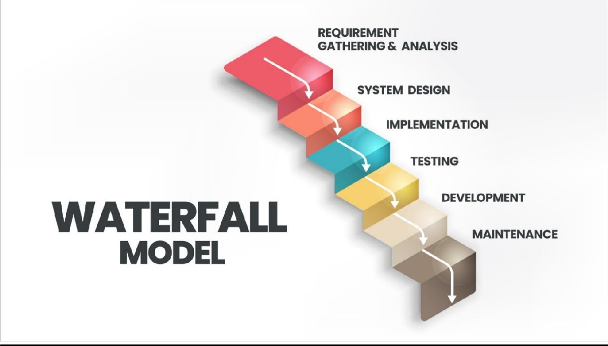

3.2 **Phases of the Waterfall Model**

**1. Requirement Analysis**

* Gather all functional and non-functional requirements of the HRMS.
* Define user roles (HR, Employee).
* Document system requirements in a Software Requirement Specification (SRS).

**2. System Design**

* Design the System Architecture (Backend, Frontend, Database).
* Create Entity-Relationship Diagram (ERD) for the HRMS database.
* Develop Data Flow Diagrams (DFD) to understand data movement.
* Define the User Interface (UI/UX) Design for HR and Employee panels.

**3. Implementation (Development Phase**)

* Frontend Development: Using HTML, CSS, JavaScript, and Bootstrap for UI.
* Backend Development: Using PHP for logic and MySQL for the database.
* Integrations: Razor pay for payroll payments, Email for login credentials.
* CRUD Operations: Implement Add, Edit, Delete, and View functionalities for employees, projects, and attendance.

**4. Testing**

* Perform Unit Testing for individual modules (Employee, Payroll, Attendance).
* Check Report Generation (PDF for Attendance, Payroll Slips, and Leave Reports).

**5. Deployment**

* Host the HRMS system on a local WAMP server or a live server.
* Configure database settings and user authentication.

**6. Maintenance & Future Enhancements**

* Fix bugs and errors found after deployment.
* Improve system performance and UI/UX based on user feedback.
* Add new features like biometric attendance and AI-based HR analytics.

**SYSTEM DESIGN**

4.1 Entity-Relationship Diagram (ERD)

has

**1 n**

employee

**1**

attendance

**1**

**n**

**n**

payment

leave

payroll

4.2Data Flow Diagrams (DFD)

**0 Level DFD**

login login

Employee

HR

request response

**1 Level DFD HR panel**

employee detail employee_detail

**HR-panel**

employee detail

L

attendance_detail

attendence_details

Leave_data

Leave_details

Leave_data

project_data

project_data

project_data

payroll_data payroll_data

payroll_data

**1 Level DFD Employee panel**

employee detail

**Employee**

employee detail

employee_data

attendence_details

attendence_details

atttebdance_data

Leave_data

Leave_data

payroll_data

payroll_data payroll_data

**SYSTEM IMPLEMENTATION**

**5.1 Database Design**

**1st Normal Form (1NF)**

Each table should have a **primary key**, and each column should contain **atomic values** (no repeating groups or arrays).

**Breaking into separate tables:**

**1. Department Table**

|  |  |
| --- | --- |
| Column Name | Data Type |
| department_id | INT (Primary Key, AUTO_INCREMENT) |
| department_name | VARCHAR (255) |

**2. Designation Table**

|  |  |
| --- | --- |
| Column Name | Data Type |
| designation_id | INT (Primary Key, AUTO_INCREMENT) |
| designation_name | VARCHAR(255) |
| department_id | INT (Foreign Key → department) |

**3. Employee Table**

|  |  |
| --- | --- |
| Column Name | Data Type |
| employee_id | INT (Primary Key, AUTO_INCREMENT) |
| employee_name | VARCHAR (255) |
| email | VARCHAR (255) UNIQUE |
| contact | VARCHAR (15) |
| dob | DATE |
| salary | DECIMAL (10,2) |
| nationality | VARCHAR (100) |
| marital_status | ENUM ('Single', 'Married', 'Divorced', 'Widowed') |
| address | TEXT |
| gender | ENUM ('Male', 'Female', 'Other') |
| department_id | INT (Foreign Key → department) |
| designation_id | INT (Foreign Key → designation) |

**4. Attendance Table**

|  |  |
| --- | --- |
| Column Name | Data Type |
| attendance_id | INT (Primary Key, AUTO_INCREMENT) |
| employee_id | INT (Foreign Key → employee) |
| date | DATE |
| sign_in | TIME |
| sign_out | TIME |
| working_hours | DECIMAL(5,2) |

**5. Leave Type Table**

|  |  |
| --- | --- |
| Column Name | Data Type |
| leave_type_id | INT (Primary Key, AUTO_INCREMENT) |
| leave_type_name | VARCHAR (255) |

**6. Leave Table**

|  |  |
| --- | --- |
| Column Name | Data Type |
| leave_id | INT (Primary Key, AUTO_INCREMENT) |
| employee_id | INT (Foreign Key → employee) |
| leave_type_id | INT (Foreign Key → leave_type) |
| apply_date | DATE |
| start_date | DATE |
| end_date | DATE |
| duration | INT |
| leave_status | ENUM('Pending', 'Approved', 'Rejected') |

**7. Holiday Table**

|  |  |
| --- | --- |
| Column Name | Data Type |
| holiday_id | INT (Primary Key, AUTO_INCREMENT) |
| holiday_name | VARCHAR (255) |
| start_date | DATE |
| end_date | DATE |
| days | INT |
| year | YEAR |

**8. Project Table**

|  |  |
| --- | --- |
| Column Name | Data Type |
| project_id | INT (Primary Key, AUTO_INCREMENT) |
| project_title | VARCHAR (255) |
| employee_id | INT (Foreign Key → employee) |
| status | ENUM ('Planned', 'In Process', 'Completed') |
| start_date | DATE |
| end_date | DATE |

**9. Project Employee Table**

|  |  |
| --- | --- |
| Column Name | Data Type |
| project_employee_id | INT (Primary Key, AUTO_INCREMENT) |
| project_id | INT (Foreign Key → project) |
| employee_id | INT (Foreign Key → employee) |

**10. Payroll Table**

|  |  |
| --- | --- |
| Column Name | Data Type |
| payroll_id | INT (Primary Key, AUTO_INCREMENT) |
| employee_id | INT (Foreign Key → employee) |
| present_days | INT |
| salary | DECIMAL (10,2) |
| total_hours | INT |
| pay_date | DATE |
| payment_mode | ENUM ('DBT', 'Bank Transfer', 'Razorpay') |
| month_year | VARCHAR (7) (Format: MM-YYYY) |
| razorpay_payment_id | VARCHAR (255) |

**11. Payslip Request Table**

|  |  |
| --- | --- |
| Column Name | Data Type |
| request_id | INT (Primary Key, AUTO_INCREMENT) |
| employee_id | INT (Foreign Key → employee) |
| payroll_ids | TEXT (Comma-separated payroll IDs) |
| year | YEAR |
| reason | TEXT |
| reason_of_rejection | TEXT (Nullable) |
| status | ENUM ('Pending', 'Approved', 'Rejected') |
| request_date | DATE |

**12. Notice Table**

|  |  |
| --- | --- |
| Column Name | Data Type |
| notice_id | INT (Primary Key, AUTO_INCREMENT) |
| title | VARCHAR (255) |
| description | TEXT |
| date | DATE |

**13. Employee Todo Table**

|  |  |
| --- | --- |
| Column Name | Data Type |
| employee_todo_id | INT (Primary Key, AUTO_INCREMENT) |
| employee_description | TEXT |

**14. HR Login Table**

|  |  |
| --- | --- |
| Column Name | Data Type |
| email | VARCHAR (255) (Primary Key) |
| password | VARCHAR (255) |

**15. HR Todo Table**

|  |  |
| --- | --- |
| Column Name | Data Type |
| todo_id | INT(Primary Key ,AUTO_INCREMENT) |
| description | TEXT |

**2nd Normal Form (2NF)**

* non-key attributes must depend on the whole primary key, not just part of it.
* Since we separated related fields into different tables, we satisfy **2NF**.

**3rd Normal Form (3NF)**

* non-key attributes must not depend on other non-key attributes.
* Our tables now **only depend on primary keys**, so **3NF is achieved**

**5.2 User Interface Screenshots**

HR LOGIN PAGE: -

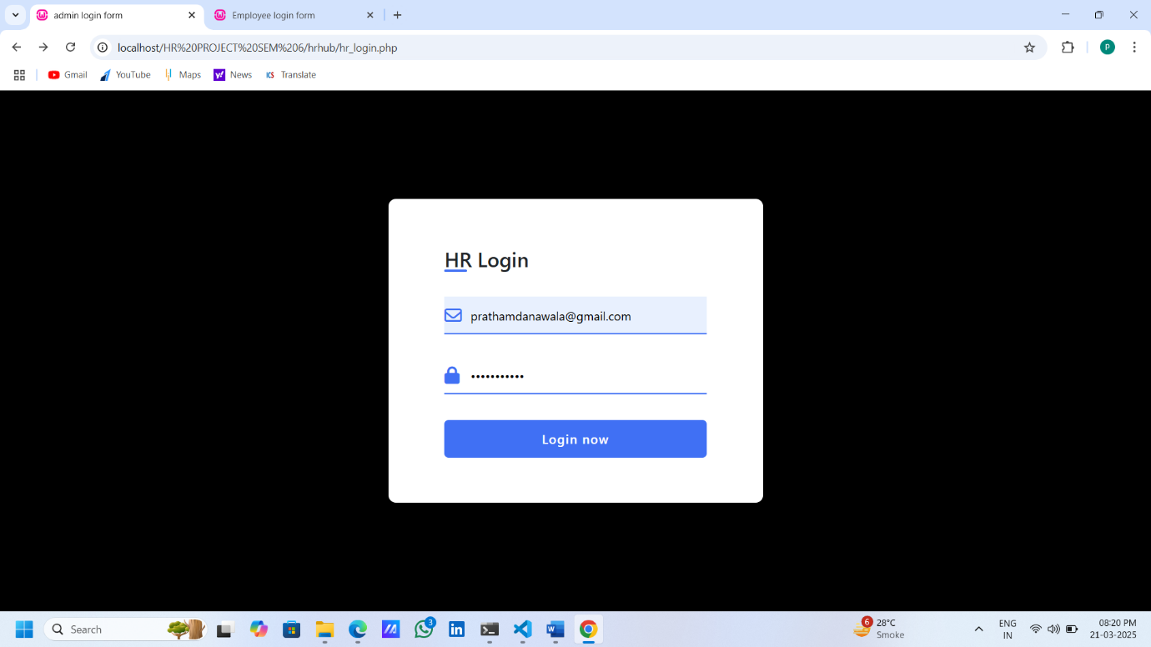

OTP Verification: -

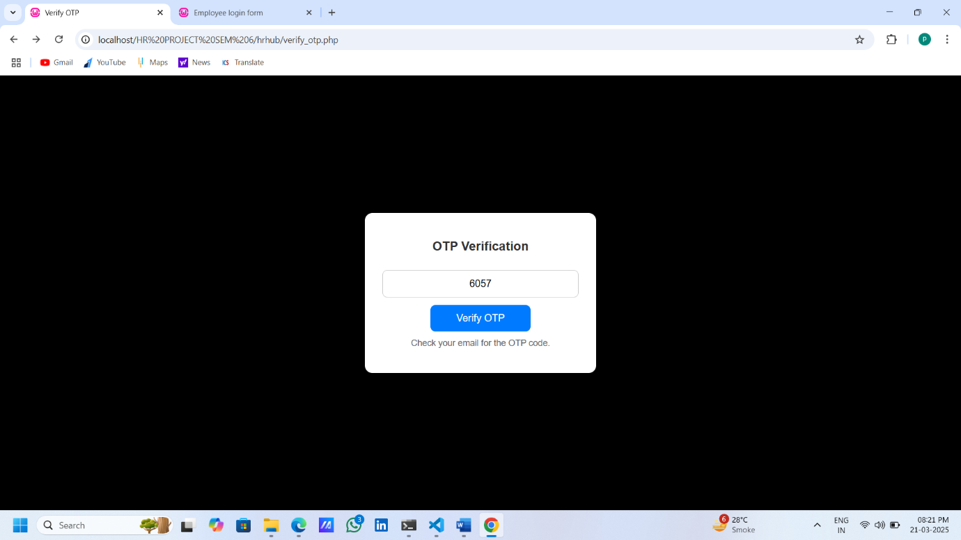

HR Dashboard: -

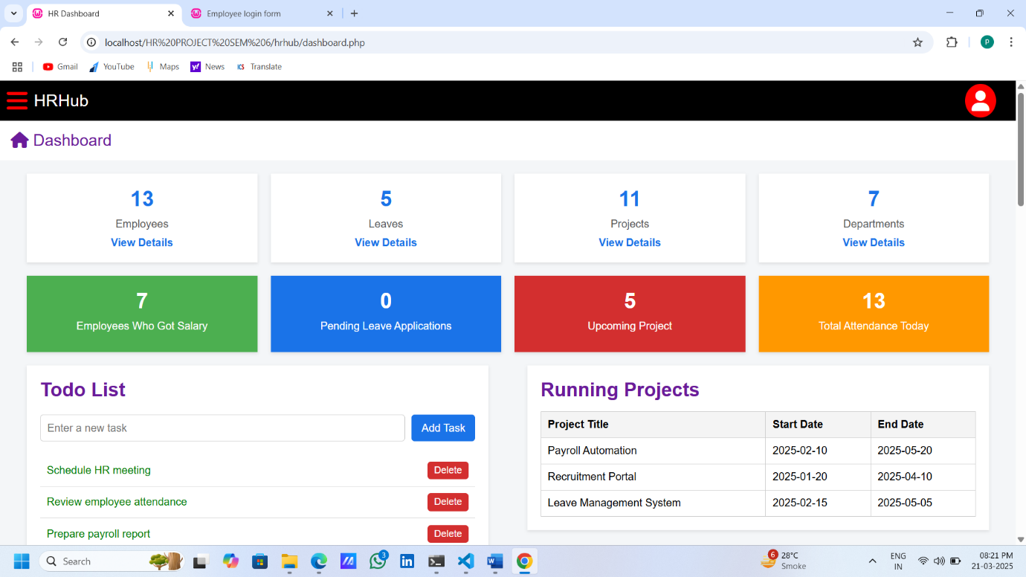

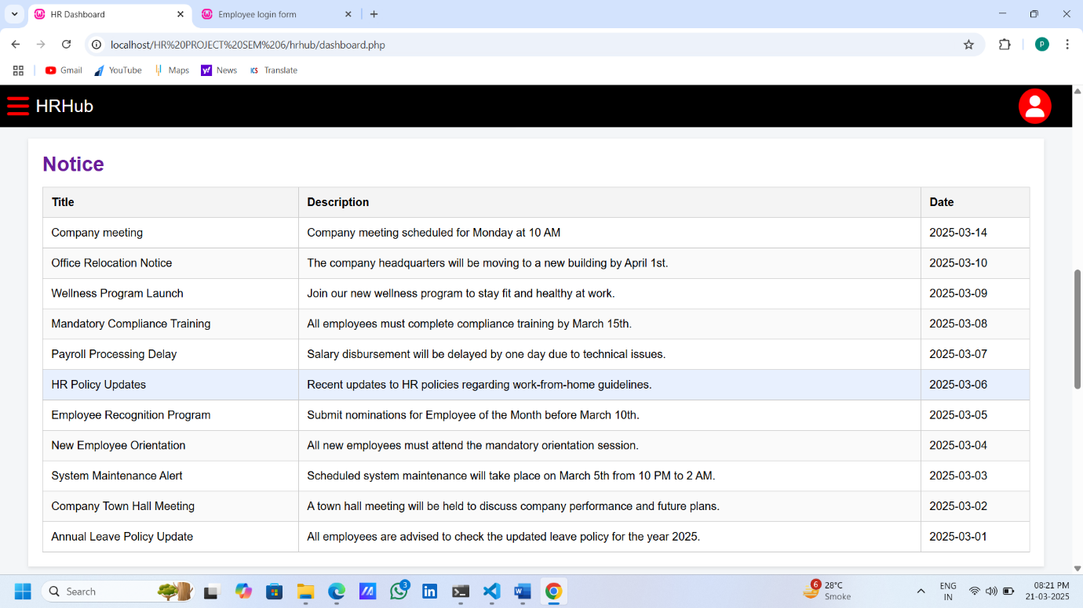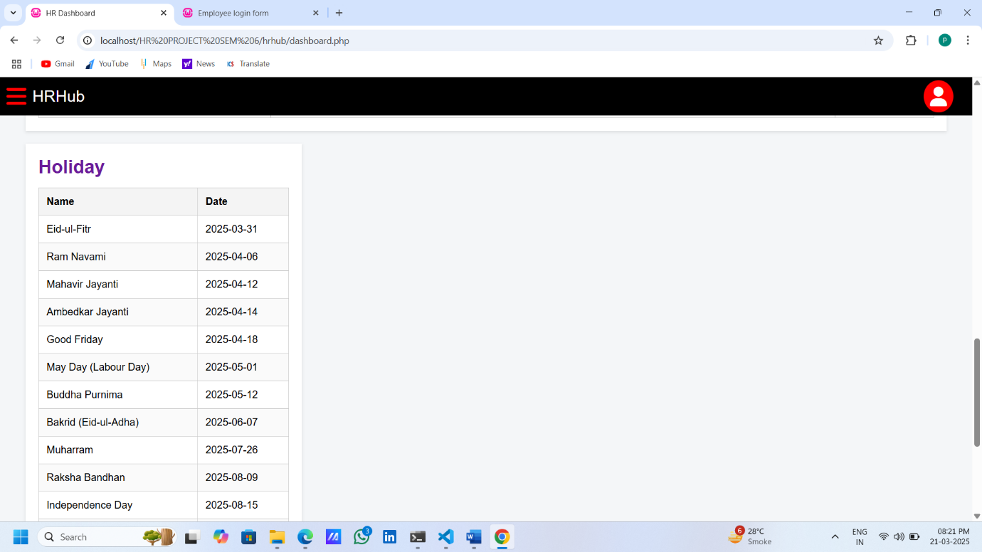

Department(ADD,EDIT,DELETE): -

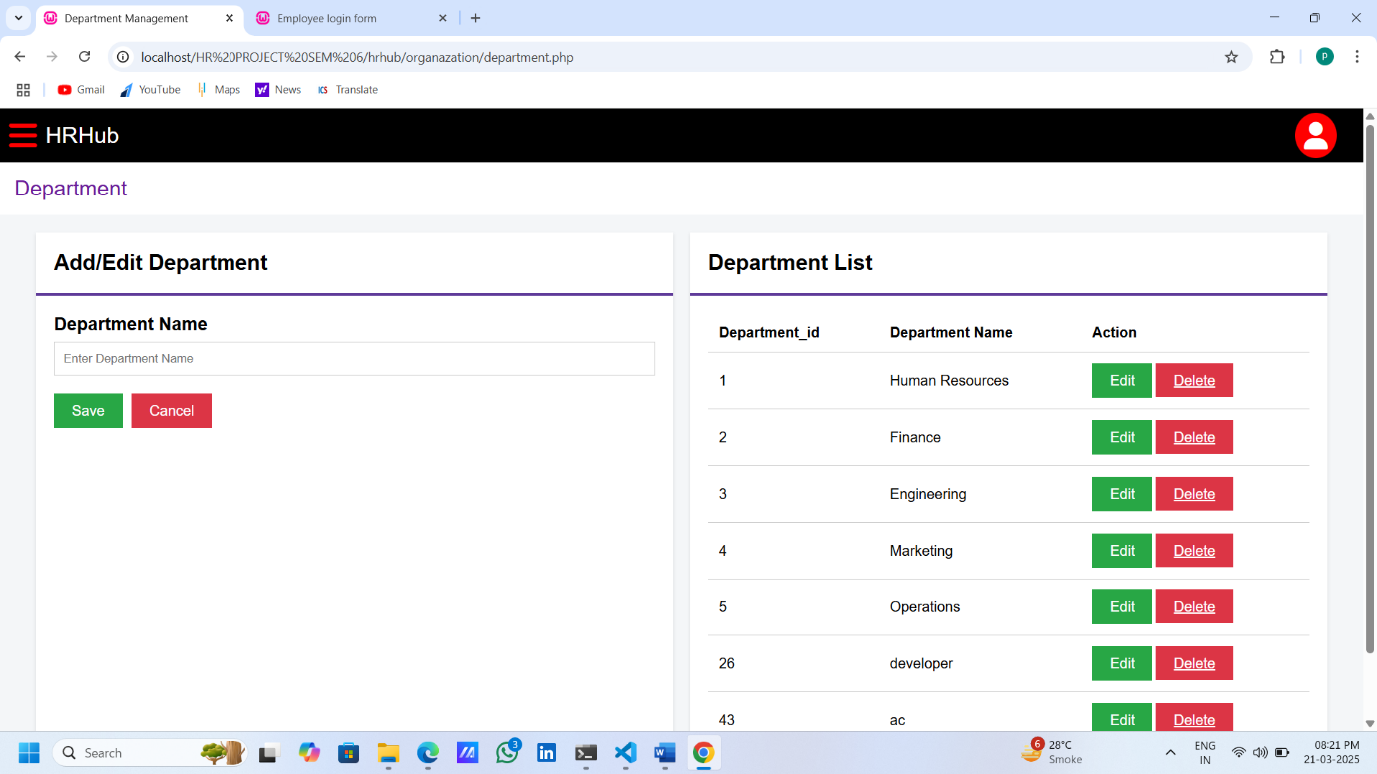

Designation (ADD,EDIT,DELETE): -

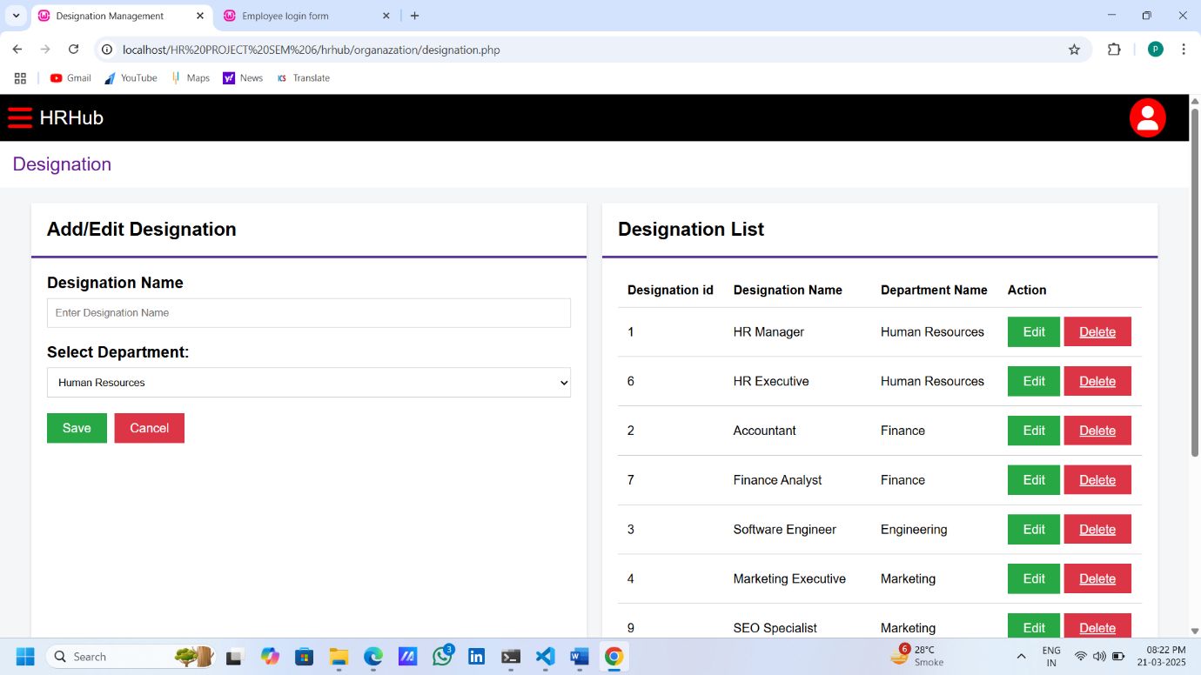

Employee(ADD,UPDATE,DELETE)

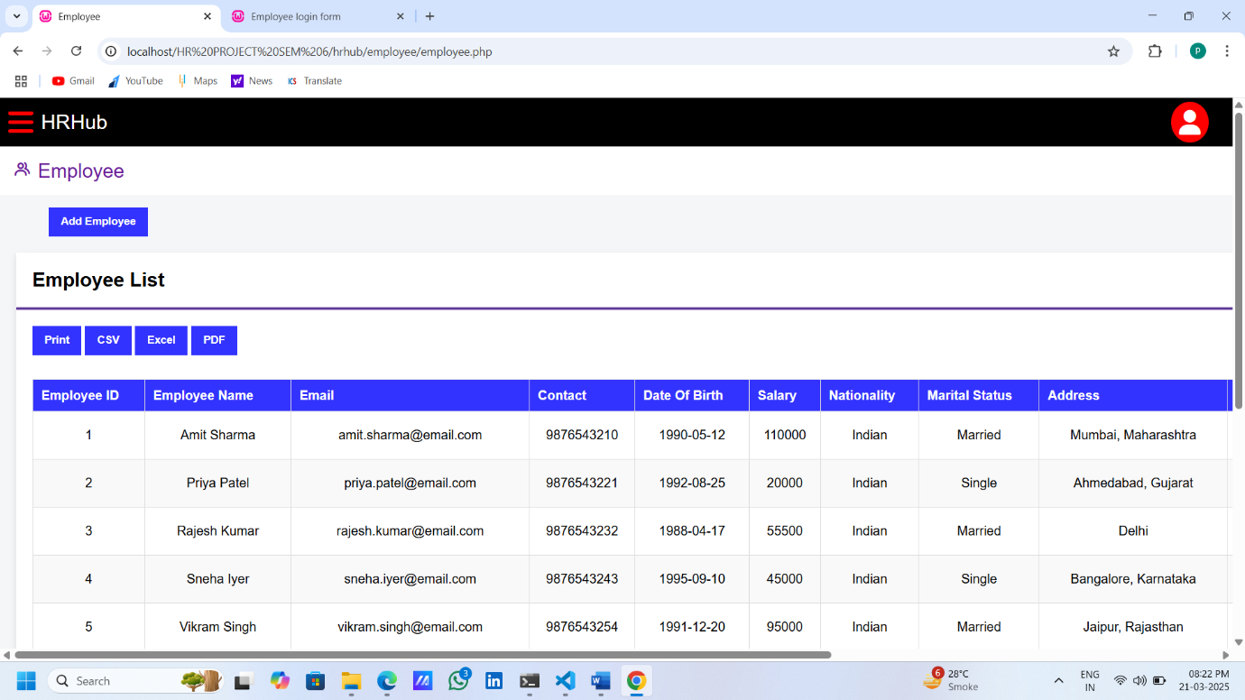

ADD Employee:-

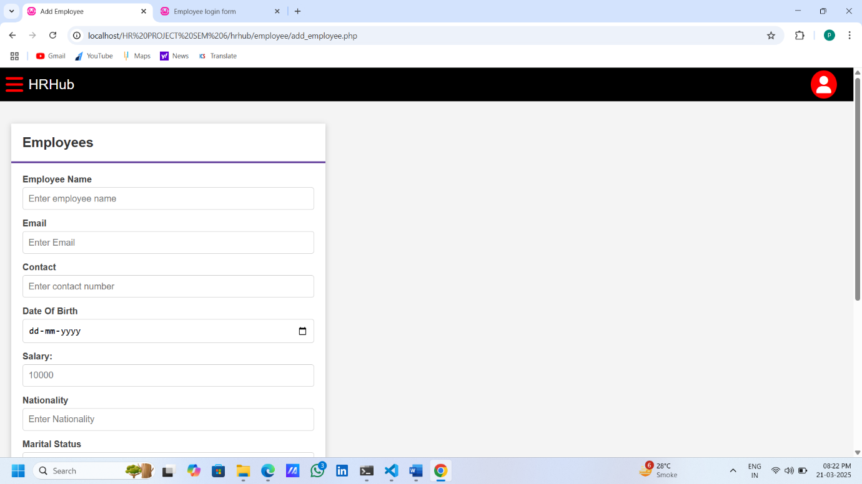

**Once Employee can Add Then Send A Email For Credential And Welcome Message**

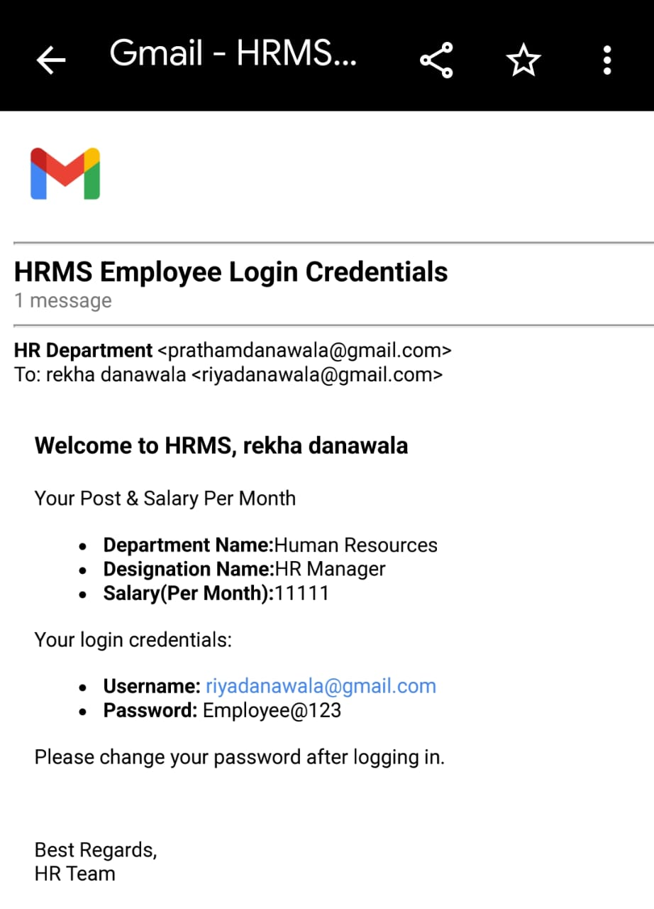

Attendance: -

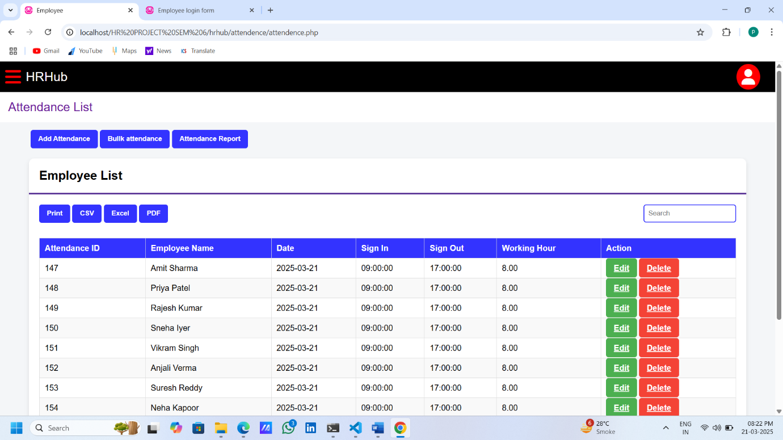

Choose Option:-

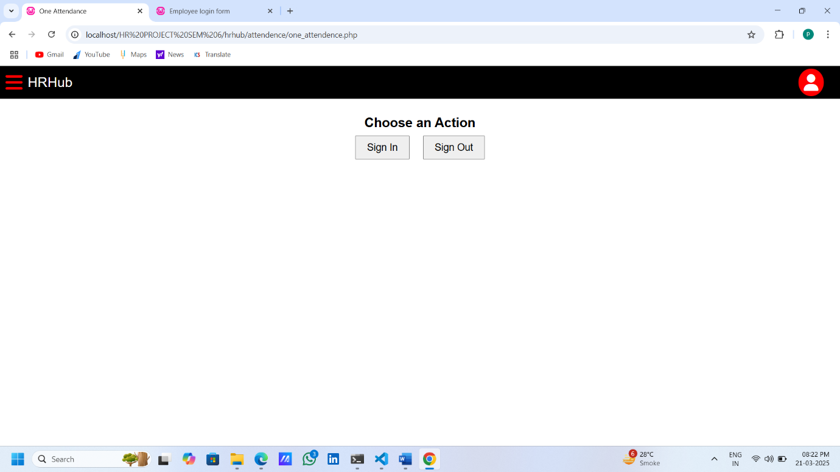

Search Employee Name :-

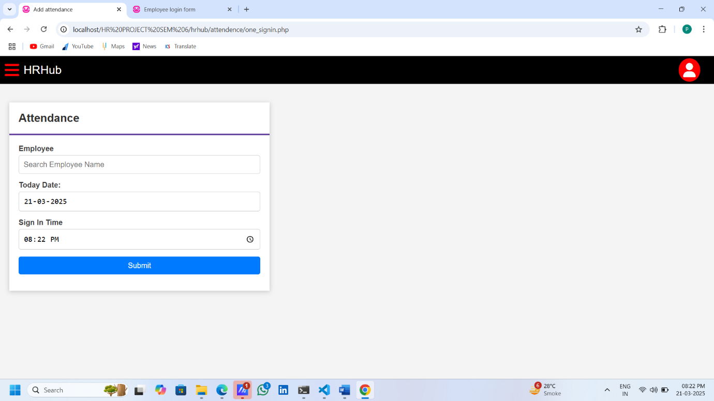

Bulk Attendance:-

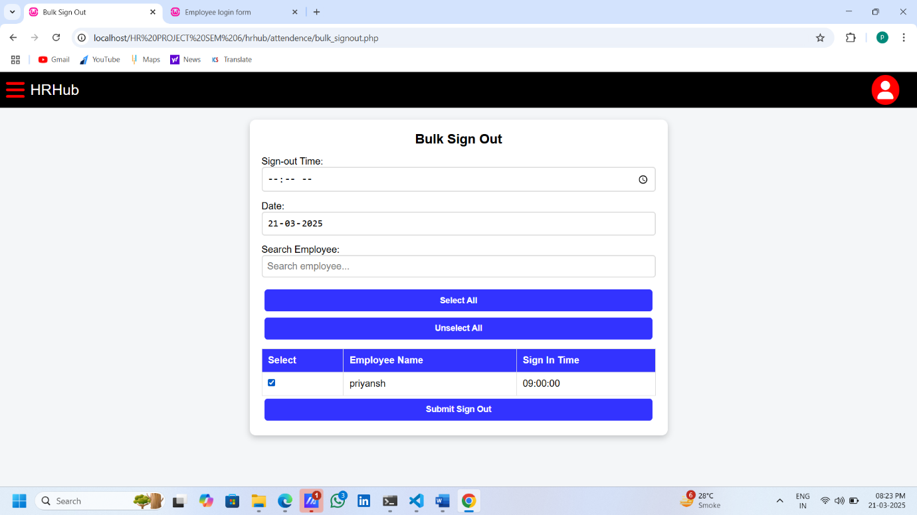

Attendance Report (PDF):-

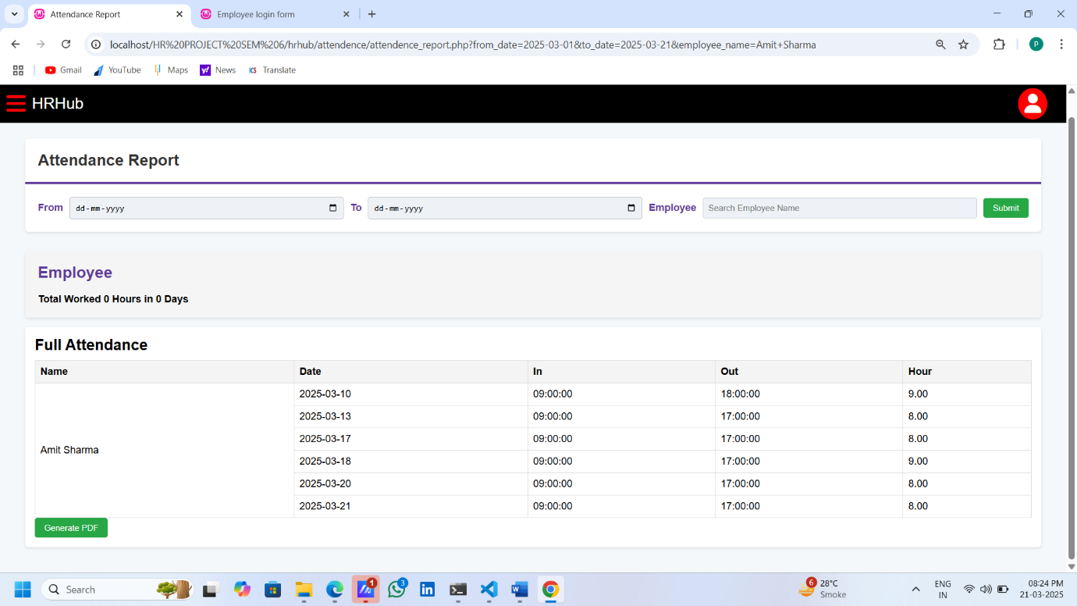

Holiday List :-

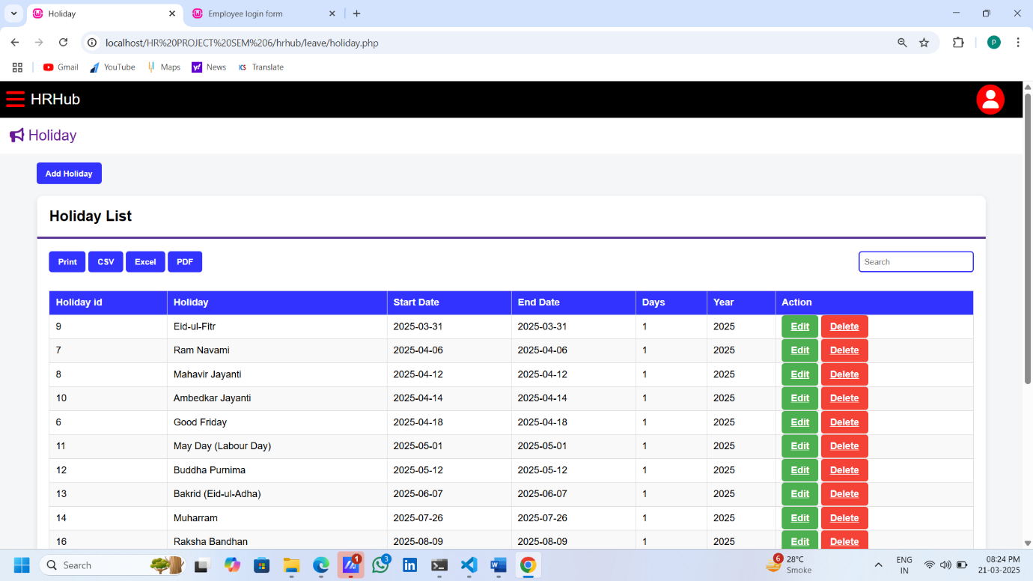

Leave Type:-

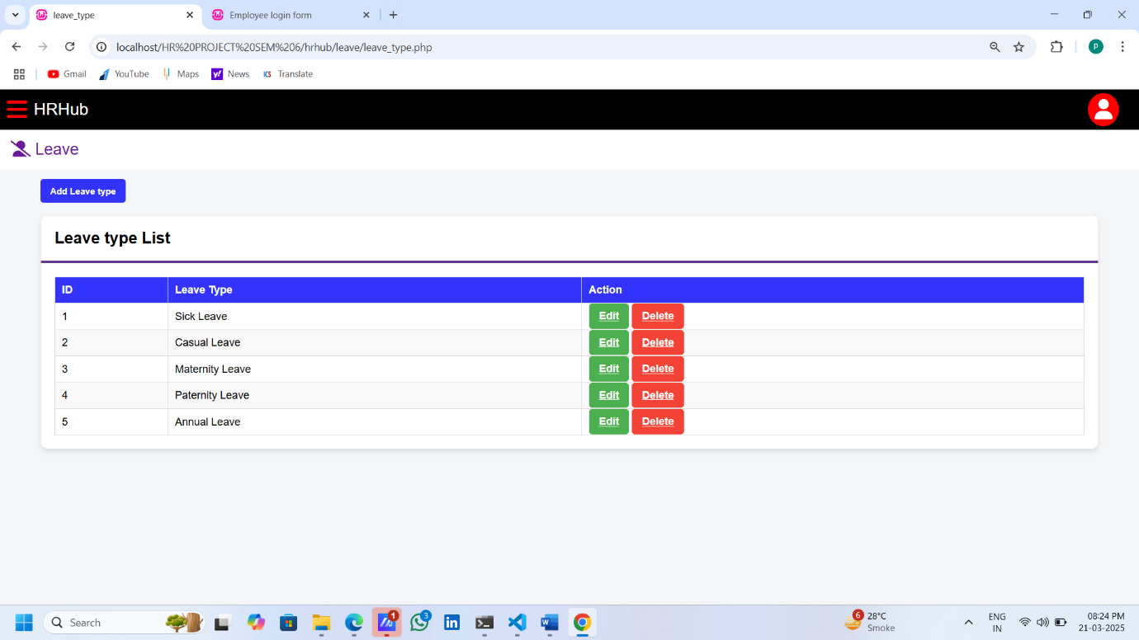

Leave Application:-

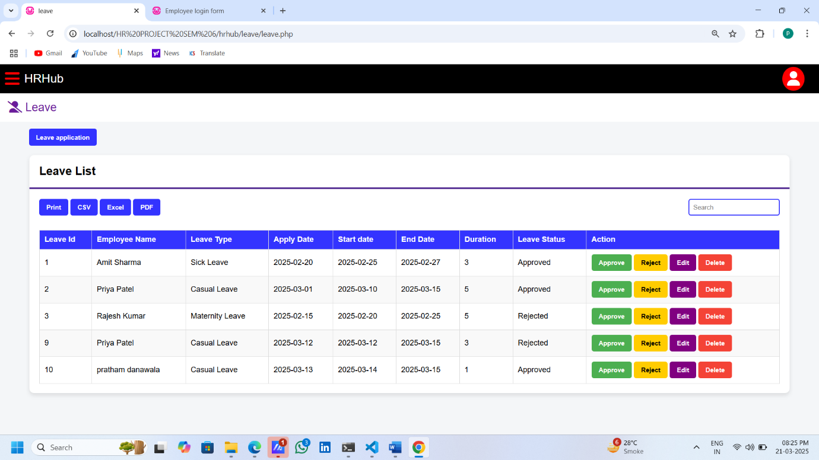

Leave Report:-

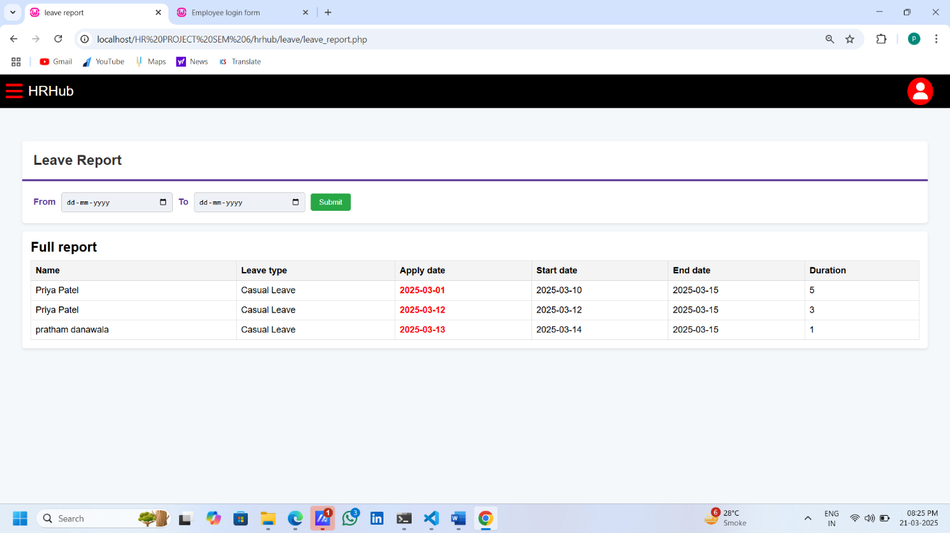

Project List:-

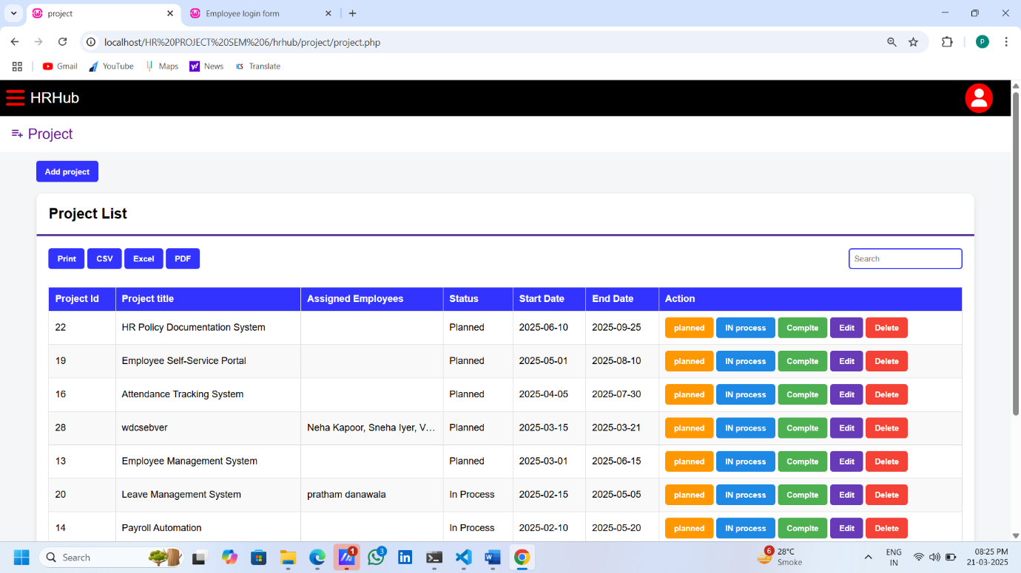

Add Project And Assign Employee:-

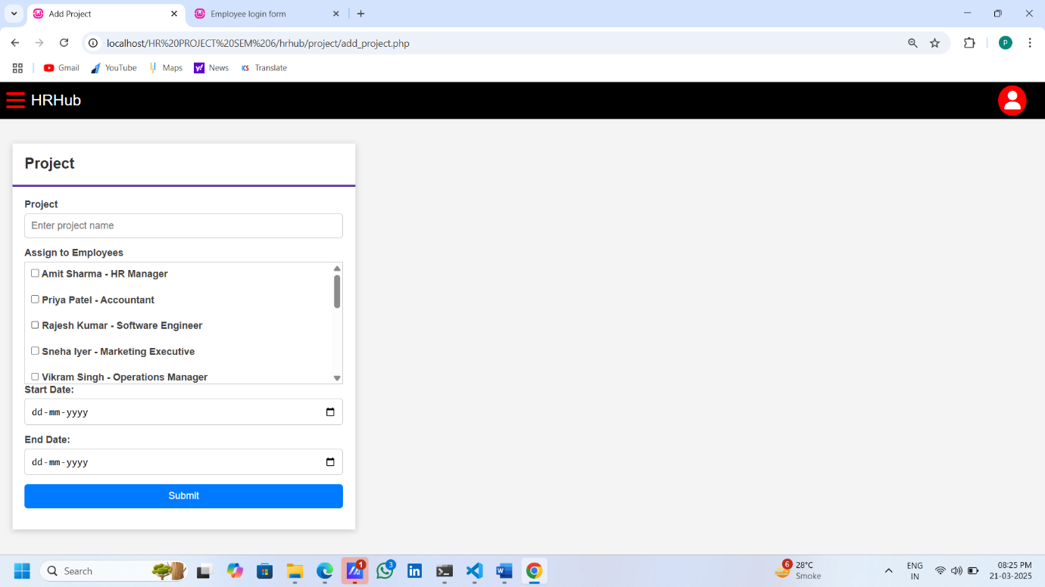

Payroll Generate:-

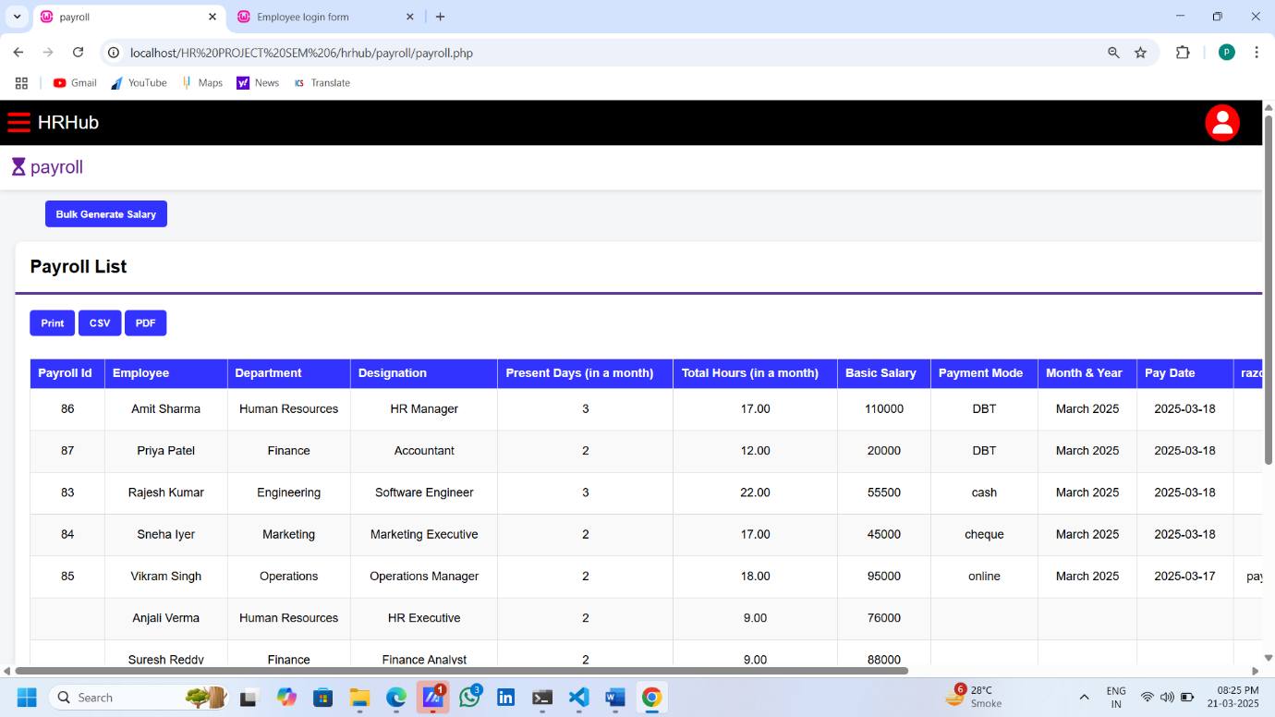

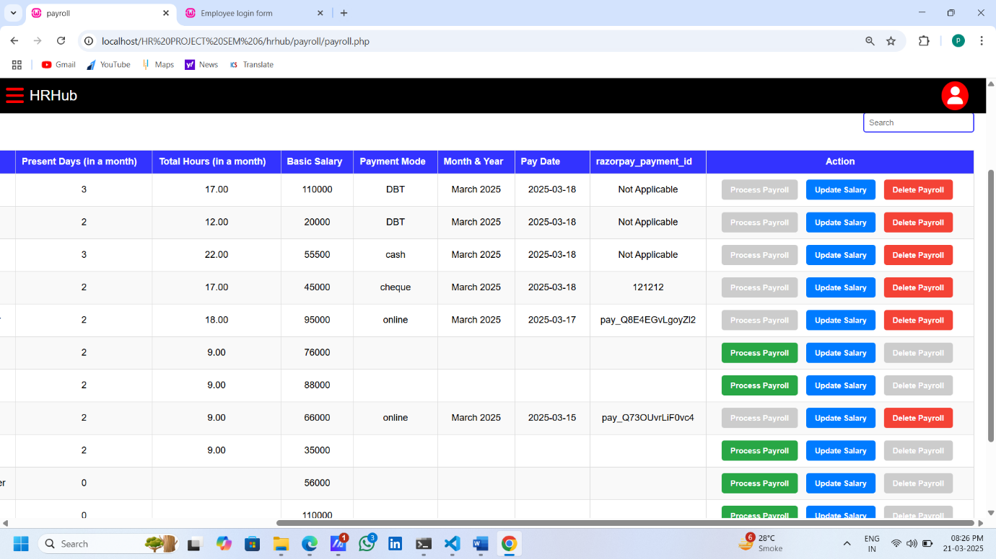

Monthly Payroll Slip Download:-

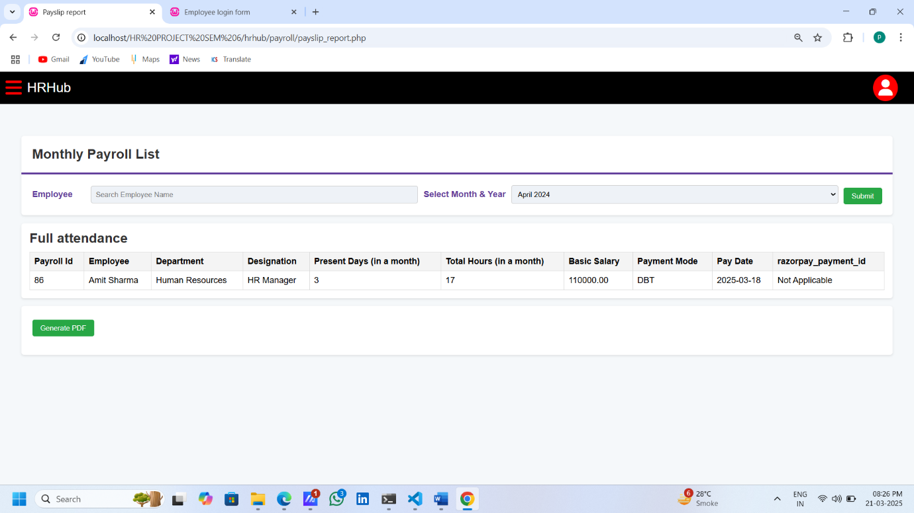

Bulk Salary Generate:-

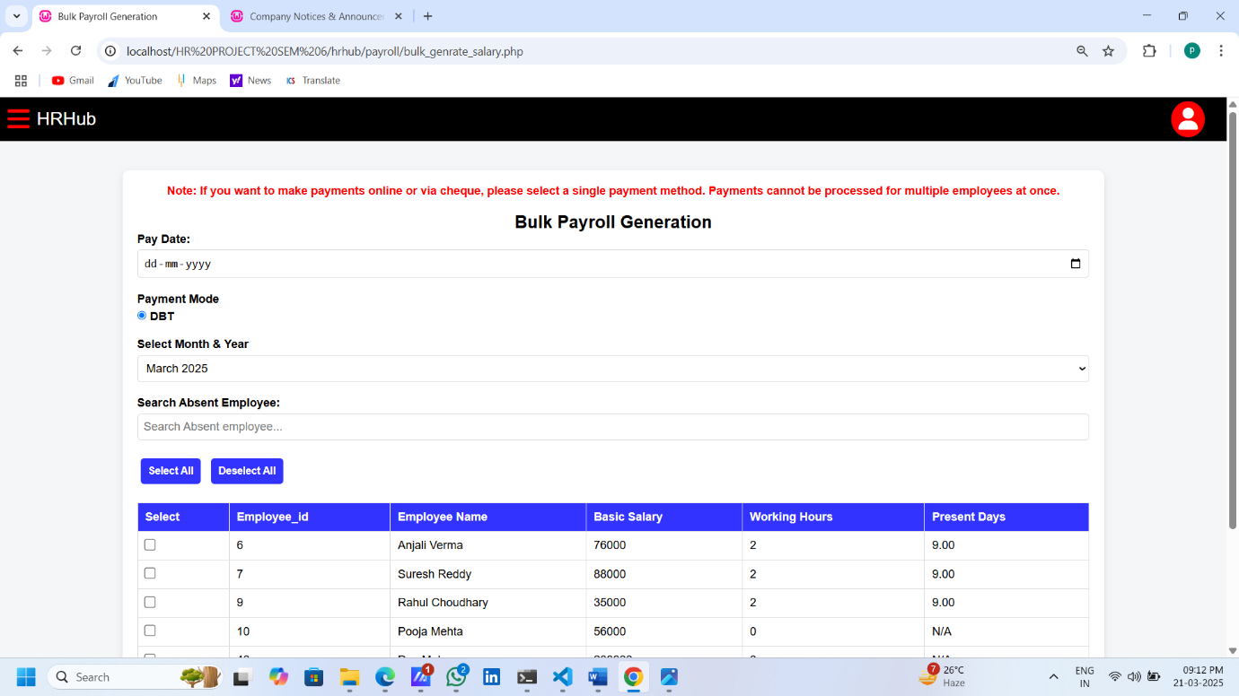

Salary Arragement:-

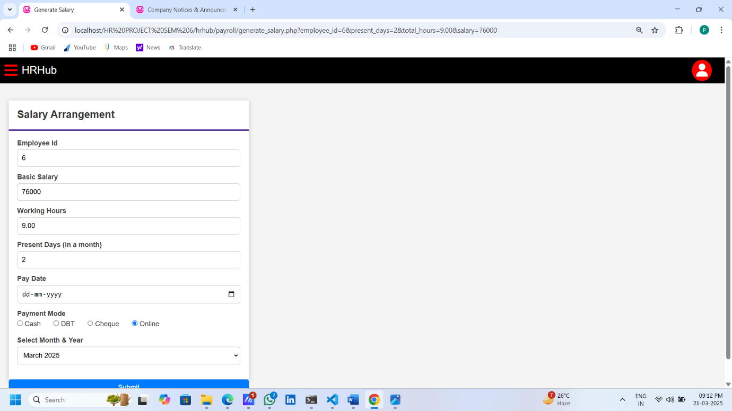

Online Payment Gateway:-

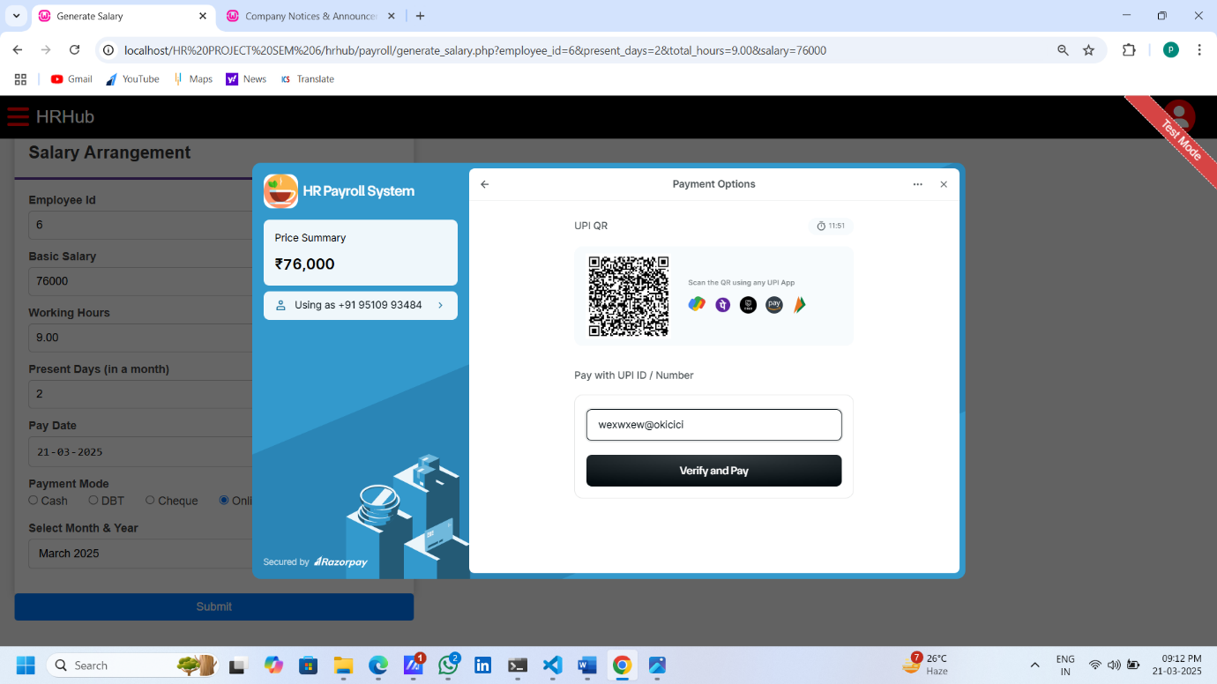

Payment Successful:-

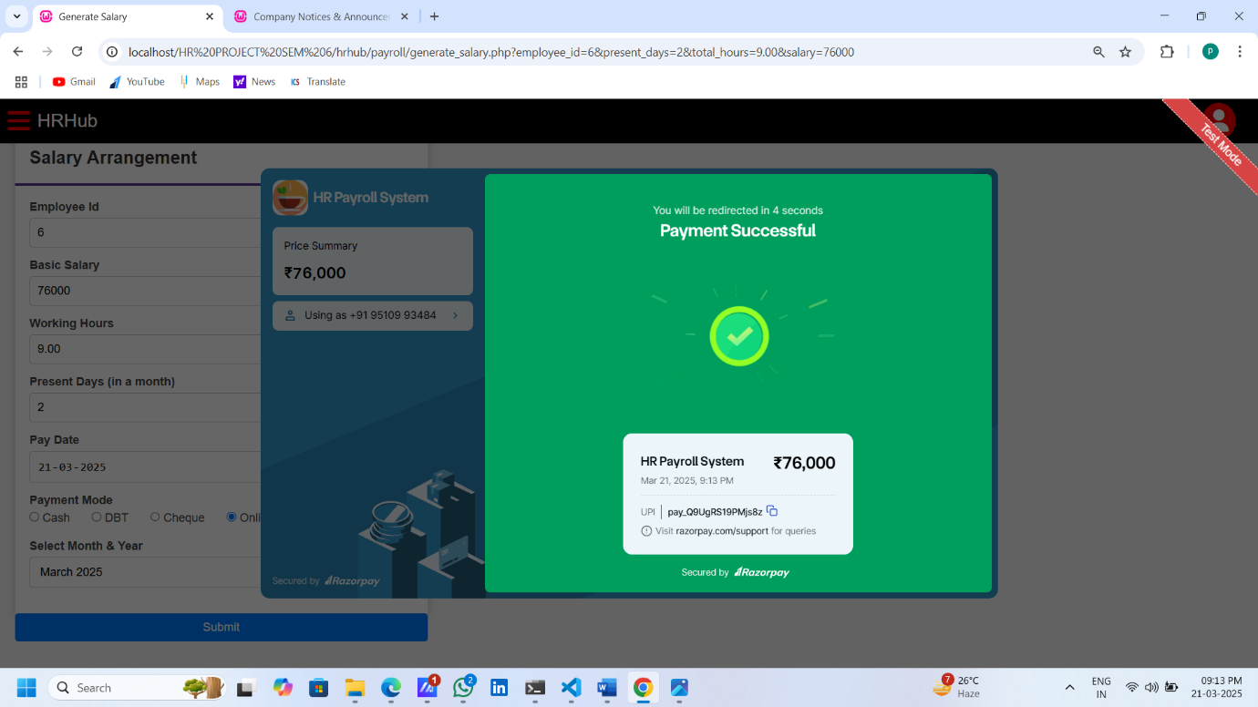

Salary Slip Request By Employee:-

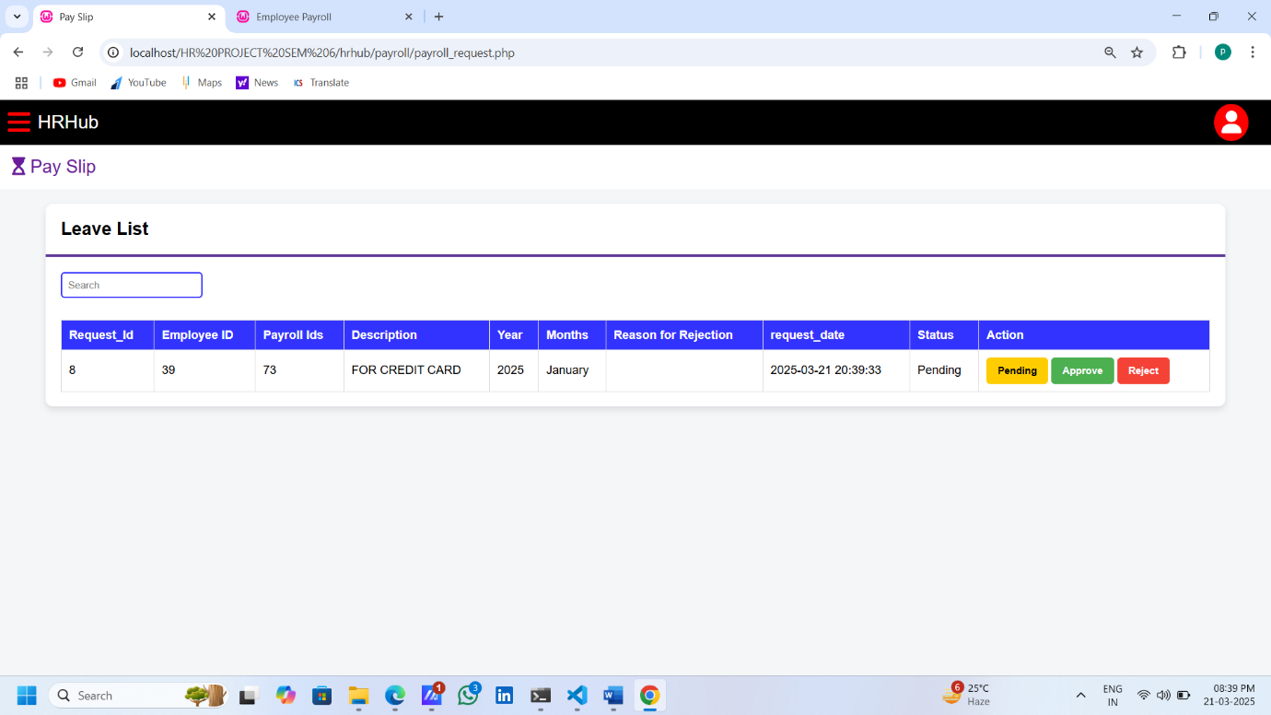

Notice :-

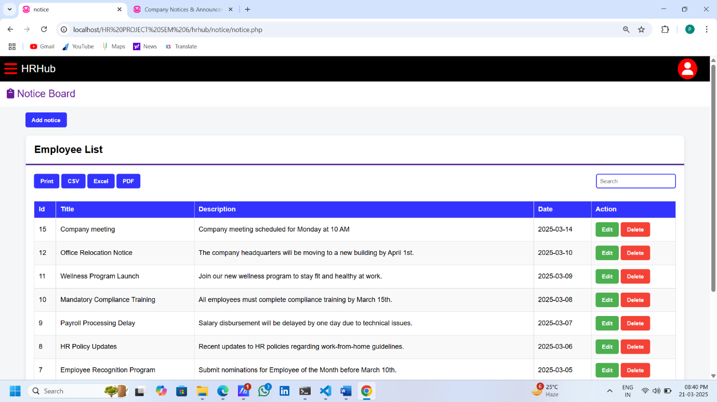

Employee Side:-

Employee Dashboard:-

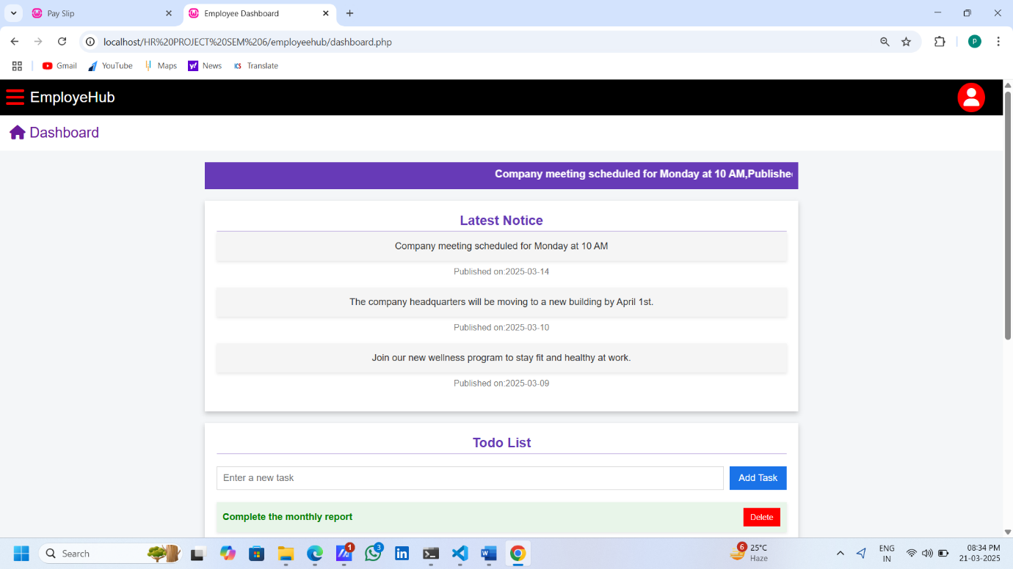

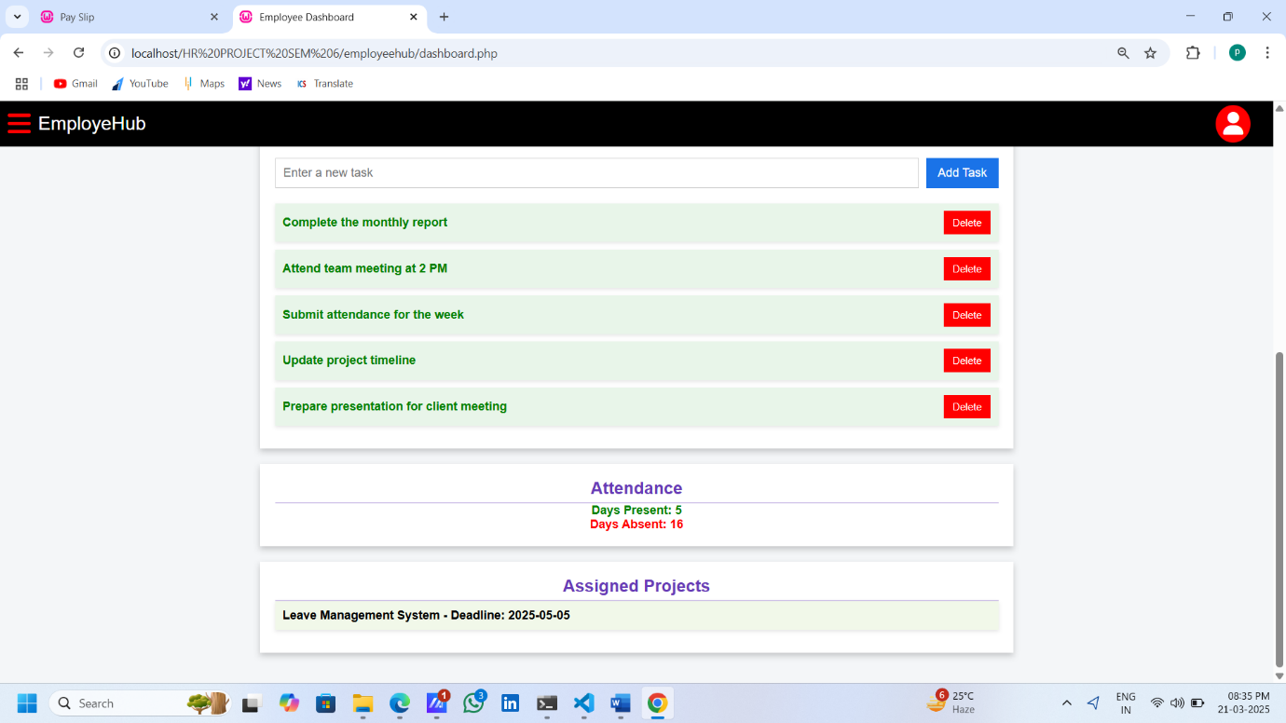

Profile Management:-

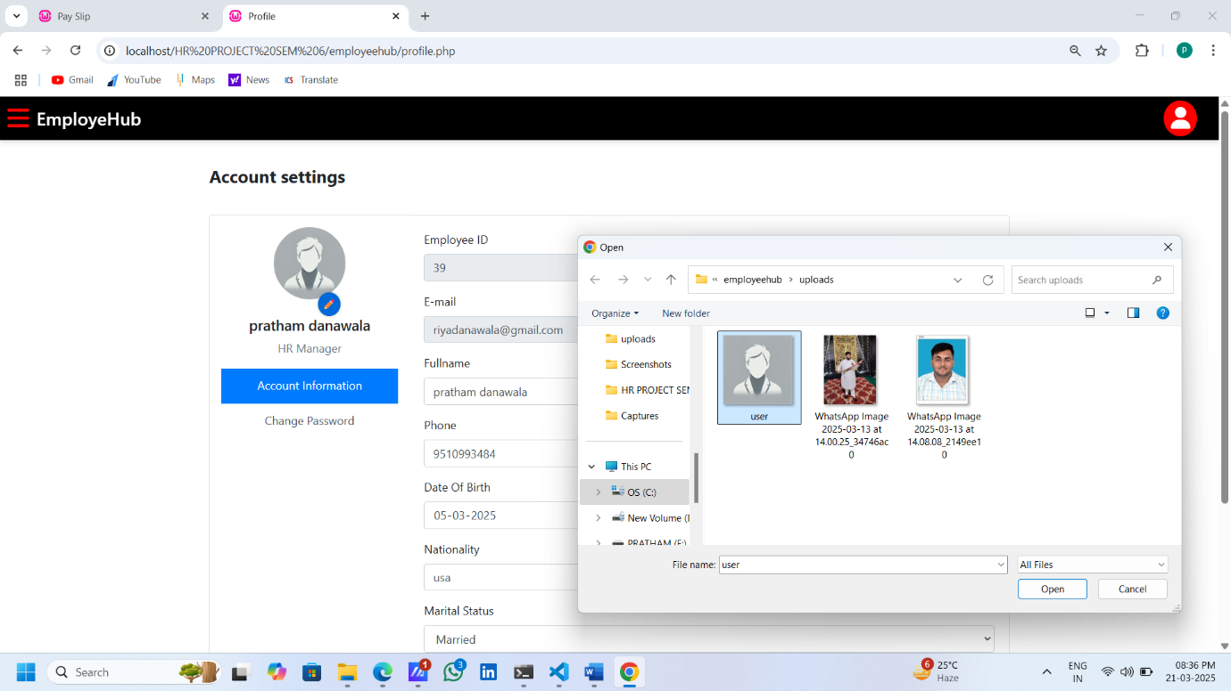

Change Password :-

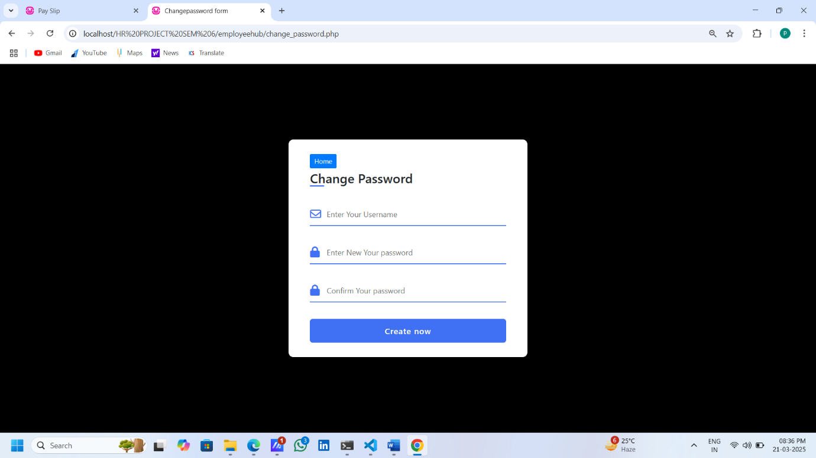

Attendance :-

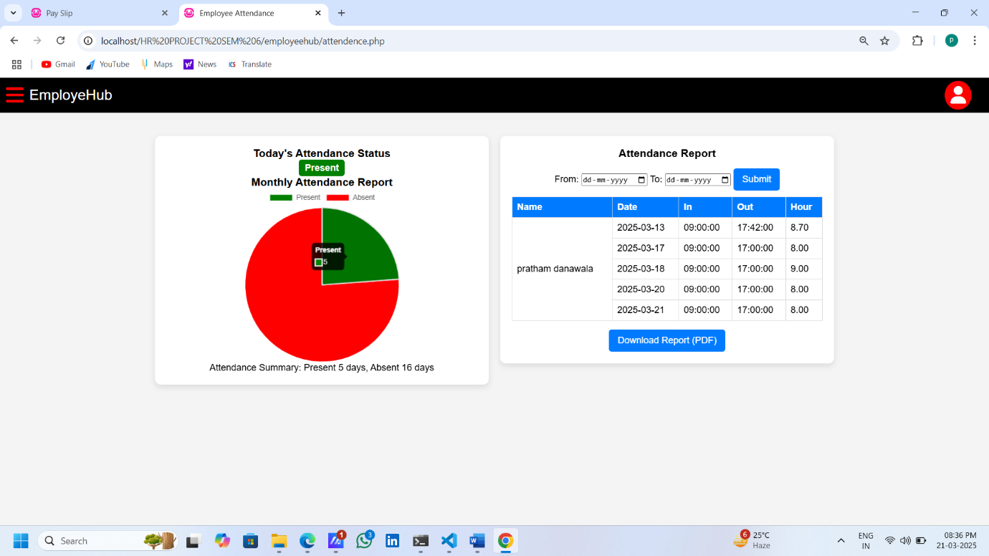

Holiday List:-

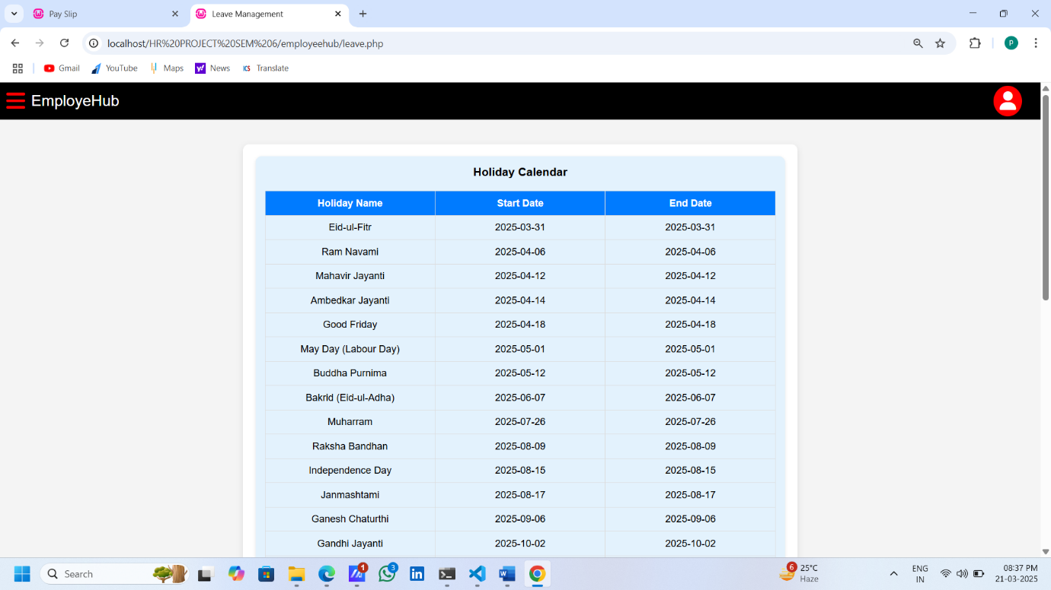

Appy For A Leave:-

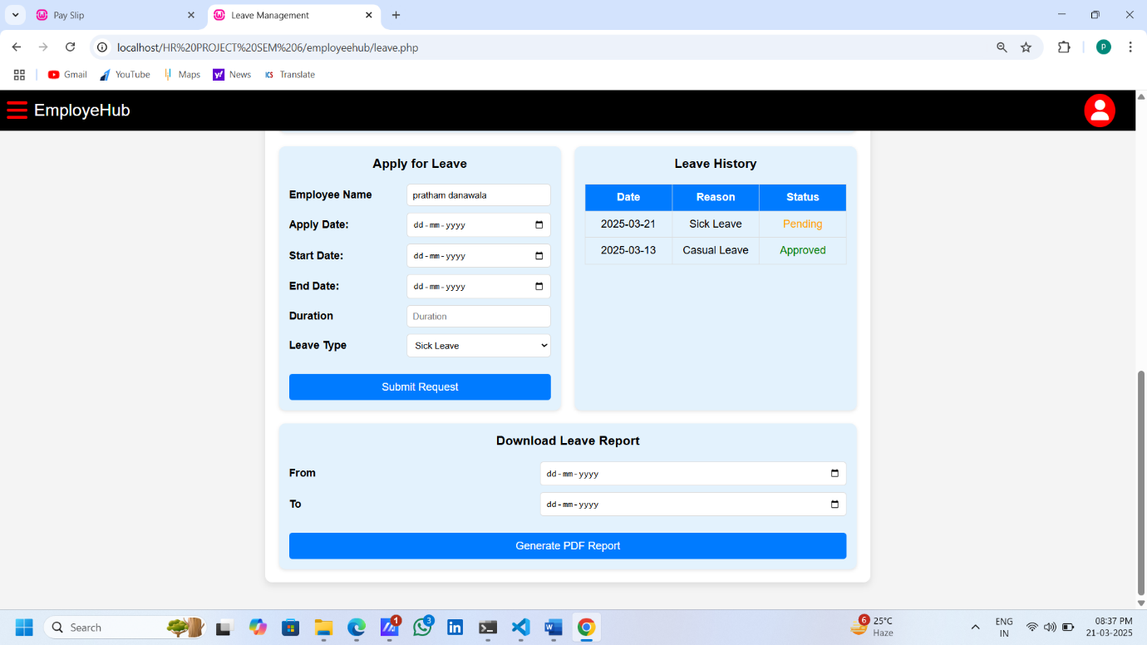

Apply For A Payslip:-

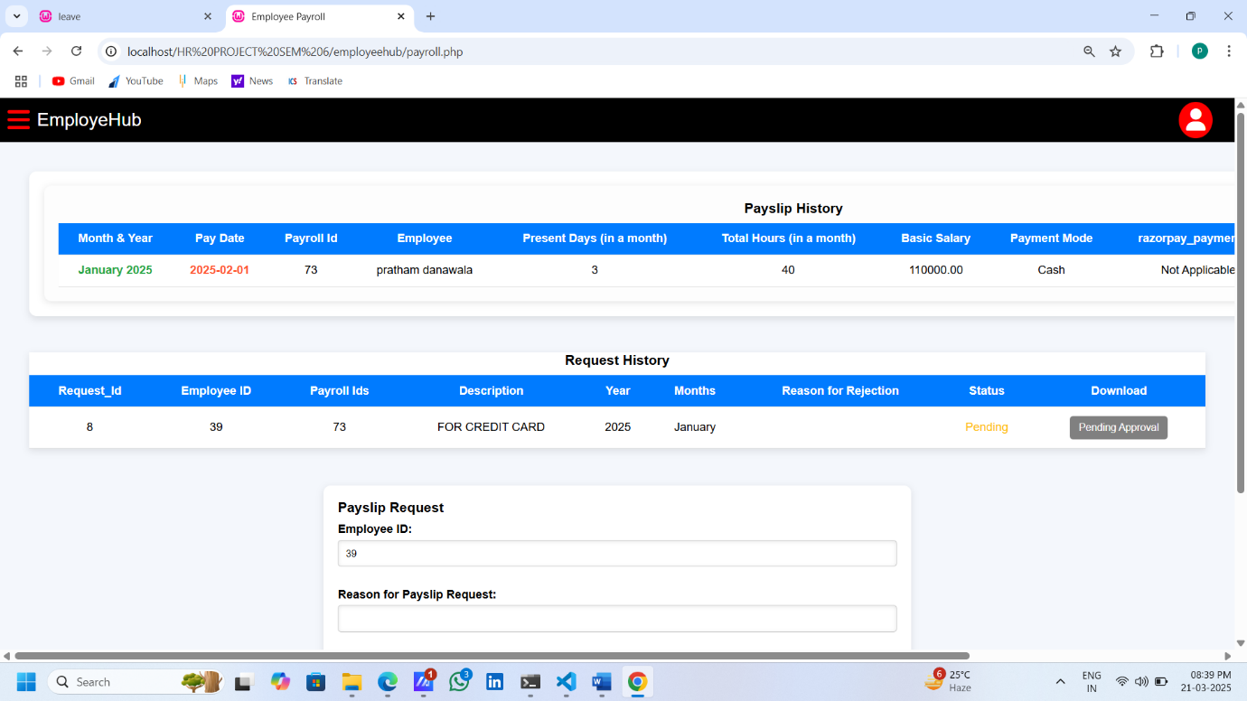

Once Approved Then Download:-

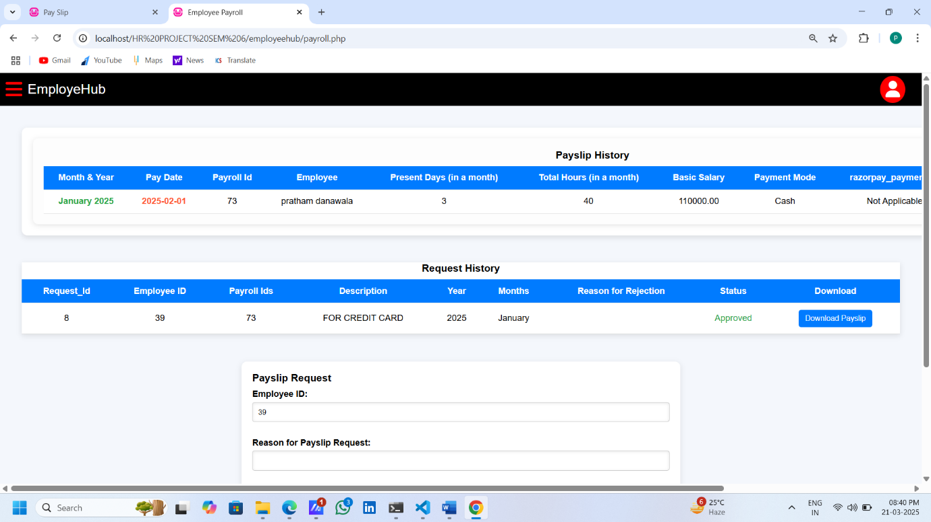

Notice Board:-

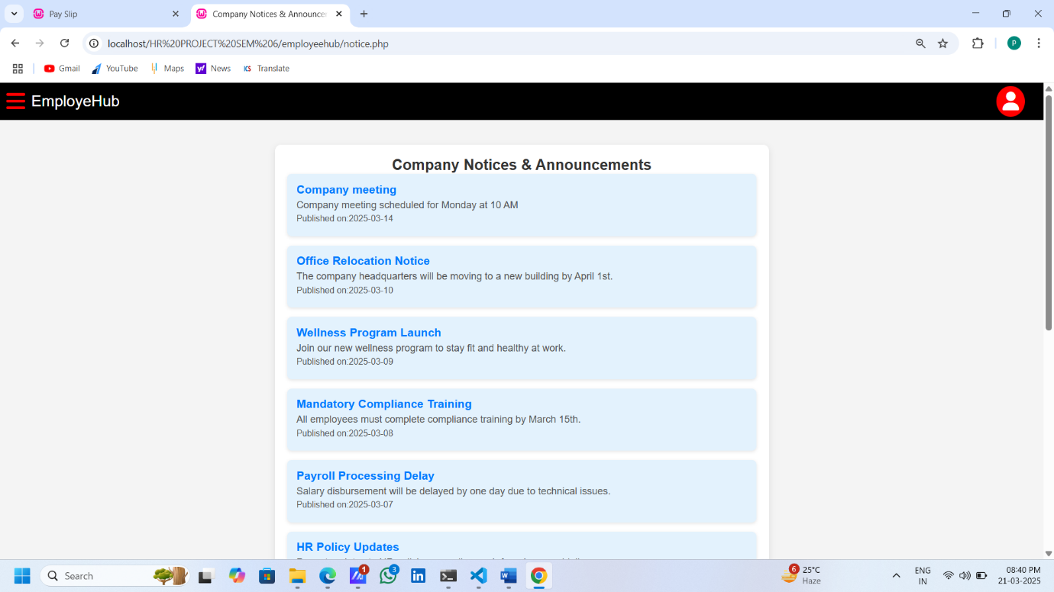

**CONCLUSION & FUTURE ENHANCEMENTS**

**7.1 Conclusion**

The HR Management System (HRMS) successfully streamlines various HR functions, including **employee management, attendance tracking, payroll processing, project assignment, and notices management**.

The system provides an efficient and user-friendly interface for both HR personnel and employees, ensuring smooth operations.

The implementation of  **online payroll processing via Razorpay, and leave management** has enhanced automation and reduced manual effort.

**7.2 Future Scope & Improvements**

While the HRMS is fully functional, there are several potential improvements and expansions for future updates:

* **Mobile App Integration** – Develop a mobile app for employees to check attendance, request leaves, and access payroll details on the go.
* **Chatbot for HR Support** – Integrate a chatbot to handle common HR queries and support requests.
* **Advanced Biometric Attendance System** – Improve attendance tracking with more **advanced face and fingerprint recognition** for seamless employee authentication.

**BIBLIOGRAPHY / REFERENCES**

[www.google.com](http://www.google.com)

[www.geeksforgeeks.org](http://www.geeksforgeeks.org)